**Assignment 2 Template**

**LAST NAME: Lawson**

**FIRST NAME: John**

**USERID: jd2lawso**

**UWaterloo ID:20466075**

**Problem 1: Fill in the information below based on your Binomial observation which was generated using your ID number as the random seed.**

**Theta = 0.319 y = 11**

**The maximum likelihood of theta is thetahat = 0.275**

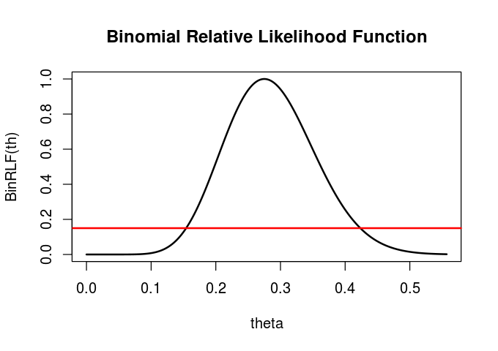

**Based on the graph of the relative likelihood function and the line y = 0.15 the 15% likelihood interval for theta is:**

**0.15-0.42**

**Using the R function uniroot the 15% likelihood interval is:**

**0.154-0.423**

**Is theta = 0.2 a plausible value of theta for your data set? Why?  
  
It is a somewhat likely value for theta, because it falls within the 15% likelihood interval**

**Is theta = 0.8 a plausible value of theta for your data set? Why?**

Theta = 0.8 is not a plausible value of theta, since it falls outside of the 15% likelihood interval.